Using Open AI and GPT-3 with Power Platform and Power Automate inside Microsoft Applications

1. Download the custom connector zip file and import it into your power platform.
2. Go to make.powerapps.com.
3. Solutions-> click on import solution and upload the zip file downloaded.
4. Now you should have custom connector ready, which makes API call to Open AI and helps you bring the power of chatgpt into your own application
5. Use the custom connector to create flow as described in the screenshot
6. Get API keys from Open AI playground here [Open AI playground](https://beta.openai.com/playground)

Scenario 1)

Creating a query bot in teams

See screenshot below.

Use Case Example: Any employe can go to teams and add a new prompt in a team's group, and they will be replied by teams with the answer

Note that ‘chatrecurring’ is the custom connector that you will download

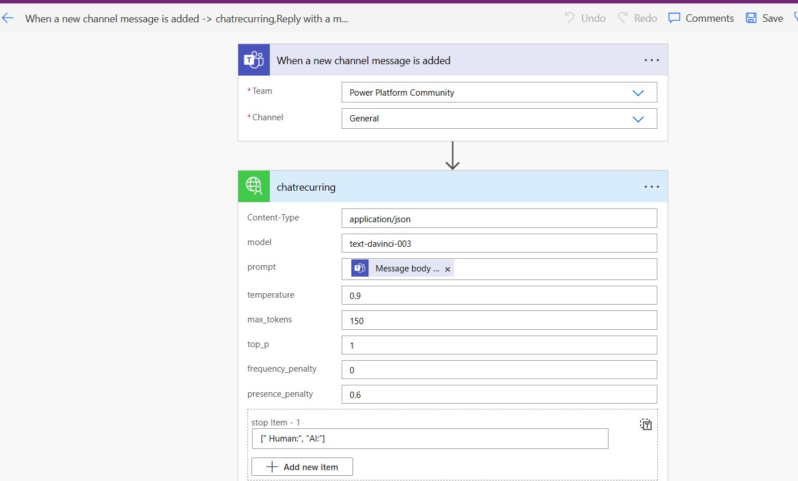

Formula expression - outputs('chatrecurring')?['body']?['choices'][0]?['text']